# Case Study: **Hotel reservation**

Capabilities used

* + HTML5 and CSS3
  + RWD
  + Bootstrap
  + JSON
  + jQuery
  + AngularJS

**Create a Single web page Hotel reservation application using HTML 5, Bootstrap, json, jQuery, underscore and AMD.**

**Features:**

Hotel reservation application should allow user to search for a hotel, view hotel details and do booking. Application should also allow user to view all reservations done by users.

Screen 1:

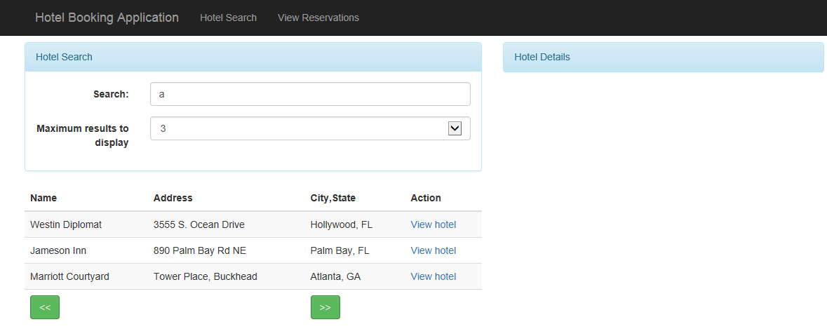

Menu has to links “Hotel search” and “View Reservations”.

Screen details:

1. Search: Hotels are filtered and displayed by “Hotel Name” based on search criteria. Search character can be in any part of hotel name, for example “a” is found in “Westin Diplomat”, “Jameson Inn”, and “Marriott Courtyard”. If user types “Ma”, then only “Westin Diplomat”, and “Marriott Courtyard” should be displayed.
2. Maximum results to display: Drop-down to specify how many records should be displayed per page. Remaining records are paginated using “>>” next and “<<” previous buttons.
3. “View hotel”: clicking on this hyperlink details of that hotel is displayed as shown below in screen 2.

**Screen 2:**

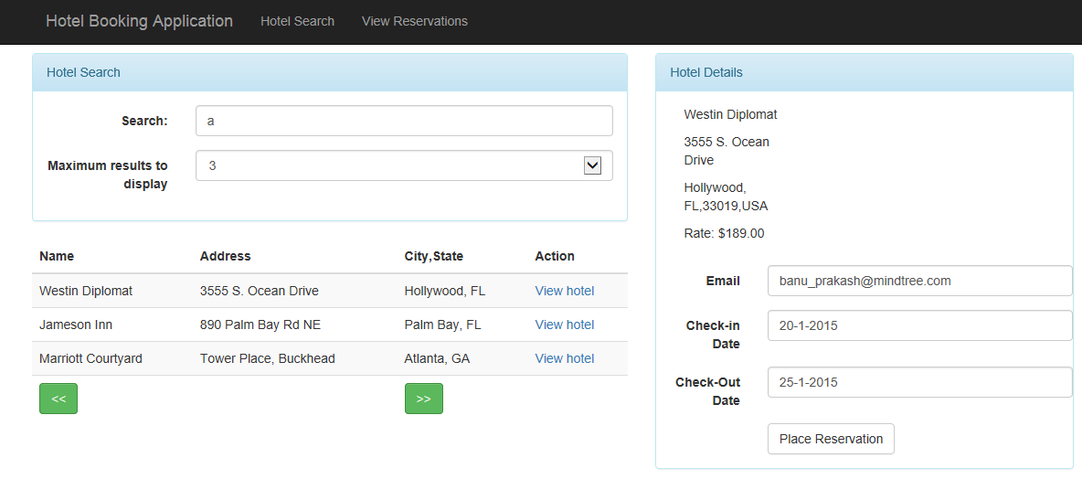

Once User enters “email”, “Check-in Date” and “Check-out Date” and clicks on “Place Reservation” details has to be stored in a separate arrays as reservation JSON data. Reservation details should contain “Name of Hotel”, “email”, “Check-in Date” and “Check-out Date”.

**Screen 3:**

Clicking on “View Reservations” all the reservations placed has to be displayed as shown below:

